Core Computer Science Principles in Java (Data Structures)

Whether you’ve learned to program with Java but do not have a computer science background or if, like me, it’s been many years since you’ve set foot in a computer science classroom, then this is the section for you. In this section I present a review of some of the fundamentals of computer science and how they are implemented in Java. Specifically I present data structures: the programmatic containers for objects.
In this section you’ll learn differences between hash tables and trees, when to use stacks versus queues, what a heap is, and so forth. You will find many of the topics in this section in job interviews.

The Difference between Trees and Hash Tables
Java provides two primary Set implementations: the TreeSet and the HashSet. Furthermore, it provides two primary Map implementations: the TreeMap and the HashMap. When would you want to use one over the other? What’s the difference?
The short answer is that the TreeMap and TreeSet classes store their data (or keys in the case of the TreeMap) in a Tree whereas the HashMap and HashSet store their data in a Hash Table. The longer, and more important answer, lies in the difference between a tree and a hashtable. The difference can be described in two ways: (1) implementation details and (2) behavior, where behavior describes the functionality that is available as well as the performance under different conditions.
I’ll start with the hash table. A hash table is a contiguous region of memory, similar to an array, in which objects are hashed (a numerical value is computed for the object) into an index in that memory. For example, consider a hash table that holds 100 elements. A hash function would compute a number between 0 and 99 and then insert the item at that location. When that item is requested then the same hash function would compute the same number and know exactly where to go to retrieve that object. There are some details that I’ve overlooked, such as sizing a hash table appropriately, the effect of resizing a hash table, and how to handle collisions (two objects hash to the same value), but I’ll address those as they come up. The key takeaways for using a hash table are:
- Inserting an object into a hash table is a constant time operation
- Retrieving an object from a hash table is a constant time operation
Trees, or more specifically binary search trees, store their data in hierarchical a tree. Figure 1shows an example of a tree.
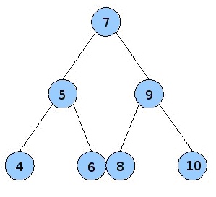
Figure 1. The Structure of a Tree
From figure 1, the top node is the “root” of the tree. The root has one child to its left and one child to its right, in which the child to its left has a lower value and the child to the right has a higher value. This requirement is maintained throughout the entirety of the tree. In this example, the root node has a value of 7: all of its left children are less than 7 and all of its right children are greater than 7. To add a new item to the tree, such as 3, we would examine the root node 7, see that 3 is less than 7, so we would go it its left child. The left child is 5, so we would again traverse to the left child. Finally, because 3 is less than 4, the new node is inserted as the left child of 4. A tree support inserting new elements at a speed that is of the order log(n), meaning that as long as the tree maintains its balance (each node has approximately the same number of children in its left subtree as in its right subtree), you will need to examine the logarithm (base 2) of the number of elements (n) contained within the tree.
Recall that log base 2 is defined as follows:
2^n = number of nodes
So in this case we have 7 nodes, so
2^n = 7, which is just a little under 3 (2^3 = 8)
This means that in order to find an object in a tree with 7 (or 8) nodes, you would need to examine 3 nodes. And the size of the tree grows rapidly with this exponent: 2^4 = 16, 2^5 = 32, 2^6 = 64, 2^7 = 128, and so on. If your tree has 128 elements, it will take 7 operations to find a location to insert a new item and it will take a maximum of 7 operations to find an object. It is not as fast as a hash table (constant time means one operation), but it is still rather fast.
And, as with hash tables, trees are not a remedy because you might have noticed that I added the warning “as long as the tree maintains its balance.” Unfortunately great effort must be expended in order to keep a tree balanced, which complicates its implementation, but there are several well established algorithms to keep a tree balanced.
Given this background that hash tables store its data in an array like structure with constant time inserts, searches, and deletes and trees store its data in a hierarchical tree with log(n) inserts, log(n) searches, and log(n) deletes, when would you use one over the other?
Looking at performance alone, the hash table is the preferred data structure to hold your set and map data, but it has some significant drawbacks:
- It requires more memory than is needed to hold its data. This is true because as a hash table becomes more and more populated, the chances for collision (two objects hashing to the same index), become more and more likely. In general, a hash table should not be more than 75% - 80% full. This means that if you want to hold 100 items, you need to have a hash table that can hold 125 – 133 elements.
- You need to know approximately how many elements you want to hold in the hash table to avoiding having to resize the hash table. For example, consider a hash table that can hold 125 elements, has 100 elements and a load factor (how full it can become before it is resized) or 80%, and the 101st is added. The hash table has crossed that 80% threshold and must be resized: simply operation, right? Wrong! The hash function computes the index for an item in the table, based on the size of the table. Therefore, as the table is resized, to say 150, all 100 objects must be rehashed to an index between 0 and 149 (instead of the previous hash of values between 0 and 124.) Rehashing is very expensive operation that requires “n” operations – so when it occurs, your constant time insert becomes of order O(n), which is far worse than the performance of a tree.
- Because hash tables compute seemingly arbitrary values for objects, there is no way to extract objects in any natural order. For example, the numbers 1, 2, 3, and 4 may come out as 2, 1, 3, 4 or 4, 1, 3, 2 and so forth. The order is determined by where the hashing algorithm inserts the objects, not on any natural order
Contrasting hash tables with trees yields the following benefits that trees provide:
- Trees only use the amount of memory needed to hold its items
- Because trees can grow and shrink as needed, they never suffer from needing to be rehashed – the balancing operation may become complex, but at no point do the insert operation approach an order of O(n) (it never needs to examine every object in the tree during an insert)
- Because trees store objects in a hierarchical structure, it is simple to extract items in their natural order (as long as that natural order defines the condition by which the tree established its hierarchical structure.)
In short, if you know approximately how many items you need to maintain in your collection, you can maintain additional unused memory in order to avoid hash collisions, and you do not need to extract items in a natural order, then hash tables are your best choice because they offer constant time insertion, search, and deletion. On the other hand, if memory is tight, you do not know how many items you may need to store in memory, and/or you need to be able to extract objects in a natural order, then a tree is a better choice.
Another condition you might want to consider when making your decision is the balance of operations that will be performed on your collection. For example, you may not know how many items you need to store in your collection (so you wouldn’t know how to best size a hash table), but you know that data will be loaded and inserted into your collection on startup and then all future operations will be searches. In this situation, you might be willing to accept rehashing your table (possibly multiple times) during startup to gain constant time search. On the other hand, if items will be consistently added and removed and you do not know how many items will be stored in your collection, then you might be willing to accept O(log n) search time to avoid potentially rehashing a table at runtime.
The point is that there is no general correct answer to whether a hash table or a tree is better, the nature of the data and the nature of the operations you will be performing on that data will determine the correct solution. The key is for you to understand how both solutions work and the benefits and tradeoffs of both solutions so that given the constraints of the problem, you are equipped to make the best decision.

The Difference between Arrays and Linked Lists
There are several occasions in programming in which you want to store a list of objects and Java provides two primary list implementations: ArrayList and LinkedList. The ArrayList is backed by an Array whereas the LinkedList is backed by a linked list. To effectively choose which one to use to solve your business problem, you need to understand how arrays and linked lists are implemented, which will reveal when one is preferable to the other.
Figure 1 shows an illustration of an array.
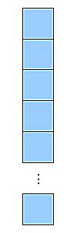
Figure 1. Array
An array is represented by a region of contiguous memory in which each object can reside in a specific “slot” of that memory. Each slot holds the same sized object and it addressed by a 0-based index. Therefore, the first object is represented by index 0, the second object is represented index 1, and so forth.
The purpose in sizing the slots the same is for data access: if you want 10th item then you know that the 10th item is located at the following memory location:
Beginning of list + 9 * size of object
This point may not seem important, but it facilitates “random access” to items in the array. Random access means that you can access items in any random order without ever having to examine any other items in the array.
The following summarizes how its operations work:
- Adding an object to the array: appends the object to the end of the array and increments the size (count of the number of items in the array.) In the ArrayList implementation, if the array is full then more memory is allocated to hold the new object. Furthermore, it provides an add() method that accepts an index that defines the position it which to add the object — in this case all other items will be shifted to make room for the new item.
- Removing an object from the array: the object at the specified index is removed and all objects are shifted down to fill in the slot previously occupied by the removed object. The ArrayList provides a remove() method that accepts an object rather than an index: in this case it searches through all objects in the ArrayList and removes the first object that matches the search criteria. Note that this is far more expensive than removing an object by its index.
- Retrieving an object from the array: if you know the index of the item then it follows the aforementioned formula, which results in a constant operation. If you do not know the index then you’ll need to iterate over the list until you find the object that you’re looking for.
Traditional arrays suffer from the problem that you need to know the maximum capacity of the array before you allocate it, but the ArrayList avoids this by automatically resizing itself. You do need to be aware that the resizing process comes at a cost: whenever an ArrayList needs to resize itself, it must allocate new memory and copy the objects in the array from the original array to the new array. Under-the-hood the ArrayList resizes its array by allocating the new capacity and calling System.arraycopy() to copy the original objects to the new array using a JNI (native) call. So it is a fast copy, but a copy nonetheless.
Linked lists solve the problem of implementing a list with a different approach: conserve memory and avoid reallocating memory at the cost of random access. Figure 2 shows an example of a linked list.
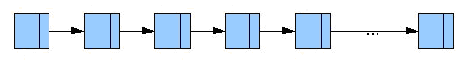
Figure 2 . Linked List
In a linked list, there is a pointer (or reference in Java) that points the first item in the list called the “head”. Rather than preallocating memory, a linked list adds items to the end of the list (the “tail”) as they are added by the client. In this way, linked lists can grow (virtually) indefinitely and only consume the amount of memory required to hold the objects, plus a pointer (reference) attached to each element that points to the “next” element in the list. The slash at the end of each node in figure 2 signifies the “next” pointer. Linked lists are probable best illustrated with a short example. Listing 1 shows the source code for a Node, which represents an element in the linked list.

Listing 1. Node.java
public class Node {
private Object o;
private Node next;

public Node( Object o ) {
this.o = o;
next = null;
}

public Object getObject() {
return o;
}

public Node getNext() {
return next;
}
}
In listing 1, the Node contains an Object, which is the contained object, and a next object that references the next Node in the list. If the next Object is null then this node is the end of the list.
Listing 2 shows the source code for a simple linked list.

Listing 2. LinkedList.java
public class LinkedList {
private Node head;

public void addItem( Object o ) {
Node node = new Node( o );

// Iterate to the end of the list
Node pointer = head;
while( pointer.getNext() != null ) {
pointer = pointer.getNext();
}
pointer = node;
}

public Object getObject( Object o ) {
// Iterate over the list
Node pointer = head;
while( pointer.getNext() != null ) {
if( pointer.getObject() == o ) {
return pointer.getObject();
}
pointer = pointer.getNext();
}
return null;
}

public void removeObject( Object o ) {
// Iterate over the list
Node prev = head;
Node pointer = head;

if( head.getObject() == o ) {
head = head.getNext();
return;
}

while( pointer.getNext() != null ) {
if( pointer.getObject() == o ) {
// Found the object, tie the previous node to point to the next element
prev.getNext() = pointer.getNext();
return;
}
prev = pointer;
pointer = pointer.getNext();
}
}
}
The addObject() method iterates over the entire list until is finds a node with a null next pointer (denoting the end of the list.) It creates a new Node object, which has a null next pointer, and assigns the last element in the list to the new node, which now represents the end of the list.
The getObject() method defines a pointer to point to the head of the list and iterates over all items until it finds the requested object. If it finds the object it returns it, but if it reaches the end of the list it returns null.
The removeObject() method is a little more complicated because after it iterates over the list and finds the object to remove it must point the previous object to the next object (effectively removing the deleted object’s reference from the list.)
The benefits to using a linked list are:
- It does not require contiguous memory
- It can grow indefinitely (you do not need to know how much memory to allocate initially like you need with arrays)
- A linked list never needs to be resized and incur the overhead of copying all elements from an original array to a new copy during the resizing process
But the problem is that all of this comes at the loss of random access. This means that if you want the 10th item in the list, you need to start from the head of the list and iterate over all 9 objects that precede the 10th object. In short, add, find, and remove can take at worst O(N) operations.
But if you will never access objects randomly and will only need to iterate over the entire collection, a linked list is a good choice. Furthermore, add operations can be optimized to be constant time by maintaining both a head and a tail object in the linked list, where the tail points to the last object in the list. As objects are added to the list they are added to the tail node and then the tail node is updated to point to the newly added node.
A final note about linked lists: you might hear someone mention a doubly linked list. The example I presented was a singly linked list, which means that you can only traverse forward from the head of the list to the tail (and if you pass an object you wanted, you cannot go back to it, you must start again at the head and re-traverse the list.) A doubly linked list maintains both previous and next pointers in the Node object so that you are free to go forward or backwards through a list. This does not really help searches, but it allows you to move more freely though the items in the list.
The differences, therefore, between arrays and linked lists are:
- If you know the indices of the objects in your list then adding, removing, updating, and removing items are constant time operations
- If you do not know the indices of the objects in your list then you need to iterate over the array to find the object, which means there is not fundamentally a difference between the performance of an array and a linked list (you might have to examine all objects to find an object)
- If memory is of paramount importance then the linked list implementation is your best choice because it only requires enough memory to hold your objects (you do not need to allocate additional memory for objects that you will use in the future)
- With the addition of a tail in the linked list, add operations are constant time for both linked lists and arrays
- Resizing an array is an expensive operation because it requires copying the original array to its new larger counterpart

The Difference Between Stacks and Queues
Traditionally, Queues and Stacks are used as containers to hold objects and retrieve them out in a specific order, which facilitates different types of operations. A Stack operates as a First In Last Out (FILO) container while a Queue operates as a First In First Out (FIFO) container. In this section I review the details of Stacks and Queues and compare scenarios in which you might want to use one over the other.
You can think of a stack like you would think of a stack of books: put one on the table, add one on top of it, add another on top of that, and so forth. Figure 1 shows how you might visualize a stack.
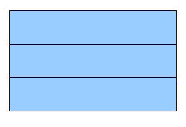
Figure 1. Stack
Items are added to the top of the stack: this operation is called a “push”, shown in figure 2.
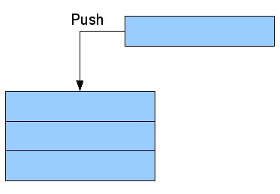
Figure 2. Pushing an object onto a Stack
Once an item has been pushed onto the stack, it must be popped off, but just like a stack of books, you have the pop off the top one before popping off any others. Figure 3 shows an item being popped off of a stack.
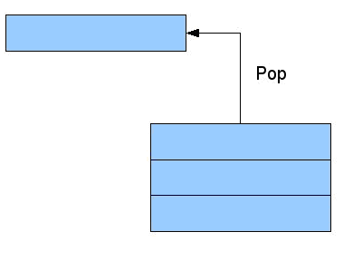
Figure 3. Popping an object off a Stack
Stacks serve many purposes and you’ll likely find them used in compilers and when performing mathematical operations. Stacks can be implemented in many different ways, such as by an array or via a reversed linked list (where there is only a tail pointer.) Listing 1 shows a simple implementation of a stack.

Listing 1. ArrayStack.java
public class ArrayStack
{
private Object[] objects;
private int topIndex = -1;

public ArrayStack( int size ) {
objects = new Object[ size ];
}

public void push( Object o ) {
if( topIndex < objects.length ) {
return;
}
objects[ ++topIndex ] = o;
}

public Object pop() {
if( topIndex == -1 ) {
return null;
}
return objects[ topIndex-- ];
}
}
Listing 2 shows the source code for a LinkedStack.

Listing 2. LinkedStack.java
public class LinkedStack {
private Node top = null;

public void push( Object o ) {
Node node = new Node();
node.object = o;
node.next = top;
top = node;
}

public Object pop() {
if( top == null ) {
return null;
}
Object o = top.o;
top = top.next;
return o;
}
}

class Node {
public Object object;
public Node next;
}
Both the ArrayStack and LinkedStack are not production ready, but they illustrate the following points:
- There are two main operations that a Stack provides: push() and pop()
- A stack does not need to know about any of its items apart from its top
Some stacks also provide a peek() method that returns a copy of the top item without popping it from the stack.
Queues operate in the opposite order: rather than removing an item from the tail of the queue, items are removed from the head of the queue. You can think if a queue like a supermarket checkout line: you enter at the back of the line, wait your turn to check out (when everyone ahead of you is gone), and then check out. Queues are mostly used to order objects, for example: when a server receives requests from clients, it typically places those client requests in a queue. An execution thread removes items from the head queue and processes them.
Adding an object to the queue is called enqueueing and removing an item from the queue is called dequeing. Queues are typically implemented in a linked list like structure, which I built in the previous section, but I updated in listing 3 to implement a queue.

Listing 3. Queue.java
public class Queue {
private Node head;

public void enqueue( Object o ) {
Node node = new Node( o );

// Iterate to the end of the list
Node pointer = head;
while( pointer.getNext() != null ) {
pointer = pointer.getNext();
}
pointer = node;
}

public Object dequeue() {
if( head == null ) {
return null;
}
Object object = head.getObject();
head = head.getNext();
return object;
}
}

class Node {
private Object o;
private Node next;

public Node( Object o ) {
this.o = o;
next = null;
}

public Object getObject() {
return o;
}

public Node getNext() {
return next;
}
}
The enqueue() method adds an item to the end of the queue and the dequeue() method returns the item at the head of the queue, updating the head to point to the next item in the queue. A common customization that you may see in queue implementations is the notion of prioritization. In short, the notion is that items are still serviced in the order that they were received, but within their prioritization group. For example, if an item is added to a priority queue with a priority 5, followed by a 2 and a 5, the two 5’s would be executed before the 2, but the two 5’s would be executed in the order they were added to the queue.
Java provides Stack and Queue interfaces that provide a variety of different implementations. The important thing to understand is the nature of both data structures so that you will be able to understand how their functionality has been customized and how they are implemented under-the-hood. As far as usage, queues are used in applications that need to order the execution of tasks or order the items to be evaluated by a task. Stacks are used in less consumer applications, but are very useful when parsing source code, performing mathematical operations, and other technical operations like converting an infix expression to a postfix expression.

Binary Search Trees
Earlier in this series I presented a breakdown of the differences between various implementations of Java data structures, such as arrays versus linked lists and trees versus hash tables. When looking at maps we compared hash table-based maps with tree-based maps and found several conclusions:
- The order of complexity for insert, remove, and find operations is constant for hash tables and log(n) for trees (where n is the number of elements in the collection)
- Hash tables require that you know approximately how many objects you are going to hold in the collection or you run the risk of having to expand the size of the table (which requires rehashing all objects that are currently in the table)
- In order to avoid collisions, hash tables need to maintain approximately 25% empty space, thus the memory required to host a hash table is more than that of a tree
- Trees only require enough memory to host all of their objects
- Hash tables have no understanding of natural order and only store objects by their computed hashes
- Trees store their objects in natural order and hence can easily output all elements in the tree by that natural order
In short, if your application is not memory-bound (meaning that the primary performance consideration for your application is memory usage), you know approximately how many items you need to store in the collection, and you do not need to be able to output your collection in natural order, then a hash table will give you better performance and is your best choice. On the other hand, if memory is a concern or you need to be able to output your collection in natural order then a tree is your best option.
A simple Binary Search Tree (BST) is shown in figure 1.
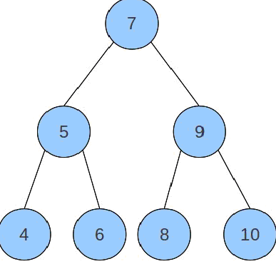
Figure 1 Sample Binary Search Tree
The following observations can be made about figure 1:
- Each circle in the tree is called a "node"
- The top node is called the "root"
- Each node can have at most two children (child nodes)
- Each node has the following property: all nodes in its left subtree are "less than" it and all nodes in its right subtree are "greater than" it
- Tree nodes without children are sometimes called "leafs"
- The height of the tree is defined as the maximum distance from the root to its further leaf, for example, the height of the tree in figure 1 is 3
While these criteria may seem like enough to define a tree, there is one important aspect of figure 1 that is implicit in our understanding, but must be qualified: the tree is "balanced." The term balanced mean different things to different implementation algorithms, but roughly it can mean that at any given node there are approximately the same number of elements in the left subtree as there are in the right subtree. Put another way, at any given node, the height of its left subtree is near the height of its right subtree.
The best way to illustrate a balanced tree is to consider an unbalanced tree. First consider building a tree with the following rules:
- If the tree is empty then the node being added becomes the root
- If the tree is not empty then search through the tree to find a home for the node: if the node is less than the one being examined then examine its left child; if the node is greater than the one being examined then examine its right child
- When you've exhausted your search, add the new node to the appropriate place on the last node examined (right or left)
For clarity I have not written these rules in any formal mathematical language, but I think a couple examples will illustrate it further. Consider the tree built in figure 1 with the following sequence: 7, 5, 6, 9, 10, 8, 4.
- The tree is empty, so 7 becomes the root
- 5 is less that 7 so it is added to the left of 7
- 6 is less than 7, but greater than 5, so it is added to the right of 5
- 9 is greater than 7 so it is added to the right of 7
- 10 is greater than 7 and greater than 9 so it is added to the right of 9
- 8 is greater than 7 but less than 9 so it is added to the left of 9
- 4 is less than 7 and less than 5 so it is added to the left of 5
This sequence of insertions is shown in figure 2.
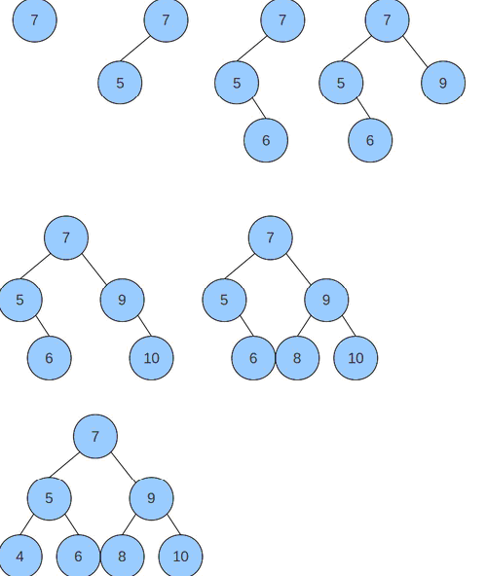
Figure 2 Building a Binary Search Tree
The power of this tree is that while it contains 7 elements, the maximum number of nodes that you need to examine before you find your node is 3. And if you consider that the order of complexity for searching the tree is the log (base 2) of the number of elements in the tree: log base-2 of 8 is 3, so with 7 items we're right on schedule.
Now consider building a tree with the same values, but in a different order: 4, 5, 6, 7, 8, 9, 10.
- The tree is empty so 4 becomes the root
- 5 is greater than 4 so it is added to the right of 4
- 6 is greater than 4 and greater than 5 so it is added to the right of 5
- 7 is greater than 4, greater than 5, and greater than 6 so it is added to the right of 6
- 8 is greater than 4, 5, 6, and 7 so it is added to the right of 7
- 9 is greater than 4, 5, 6, 7, and 8 so it is added to the right of 8
- 10 is greater than 4, 5, 6, 7, 8, and 9 so it is added to the right of 9
The result is shown in figure 3.
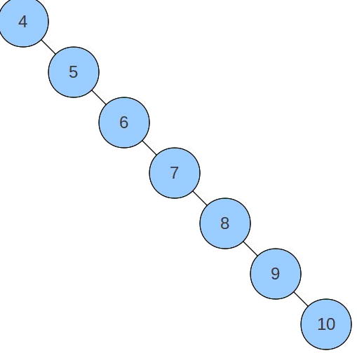
Figure 3 An unbalanced binary search tree
While figure 1 shows a balanced tree, figure 3 shows an unbalanced tree. Because of the order that the nodes were added to the tree, the tree looks more like a list than a tree. If you were to compute the worst case order of complexity for finding a node in this tree it is n rather than log(n). In other words, you may need to search 7 objects to find your object in a tree with 7 total objects. The act of maintaining the balance of the tree is what gives us our performance benefits: without balancing the tree, the performance of the tree is no better than maintaining a list.
In this section we'll explore some algorithms for maintaining and balancing trees. Specifically it will present two core algorithms: AVL trees and red-black trees. AVL trees were the first tree data structure created in 1962 and represents an easy-to-understand strategy for balancing trees. Red-black trees are less formally balanced, but yield better performance. Red-black trees are also far more difficult to understand, but with AVL trees under your belt you'll be ready to tackle red-black trees. And while you do not necessarily need to implement trees in Java on your own, it is important to know how they work – and to know that the tree implementation underneath the TreeSet and TreeMap is a red-black tree.

AVL Trees
In the previous section I reviewed the challenges that one can face when building a binary search tree and the necessity to “balance” a tree. An unbalanced tree, in the worst case, can run in O(N) time, while a balanced tree runs in log(N) time, therefore it is important for you keep your tree balanced. There are various algorithms that can be employed to balance a tree, the first of which is called an AVL Tree.
The AVL Tree algorithm was created in a 1962 paper by G.M. Adelson-Velskii and E.M. Landis (hence the AVL acronym) in their paper “An Algorithm for the Organization of Information.” And while AVL Trees are not frequently found in production code because there are better performing alternatives, they provide a great mechanism for understanding how balanced trees work.
Central to AVL Trees is the definition of the balance factor, which is defined as the height of a node's left subtree minus the height of its right subtree. If the balance factor is -1, 0, or 1 then the three is considered balanced, otherwise it is considered unbalanced and a balancing operation must be performed. The balancing operation is performed when inserting an item into the tree or removing an item from the tree. The process is to find the location where a node should be inserted, insert the item, and then check each node's ancestors to ensure that the balance factor is maintained.
The re-balancing of the tree is accomplished through tree “rotations.” Rotations can come in one of two forms: single rotation and double rotations, and each flavor has its corresponding “left” and “right” versions, depending on which side of the tree is unbalanced.
To illustrate how this works, consider building a tree with the numbers 3, 2, 1. Figure 1 shows what this tree looks like.
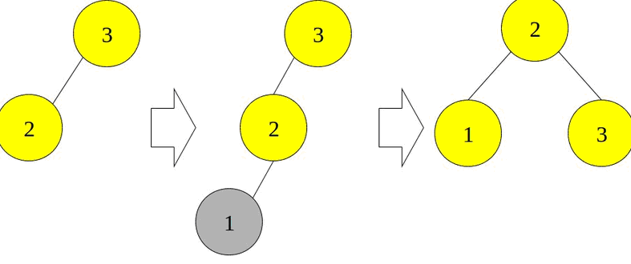
Figure 1. Single Rotation of an AVL Tree
In figure 1, when 3 is inserted the tree has a height of 0 and is balanced. When 2 is inserted then the left tree has a height of 1 and the right tree has a height of 0 so the balance factor is 1 – 0 = 1, so the tree is balanced. But when 1 is inserted then the left tree height is 2 and the right tree height is 0 so the balance factor is now 2, which violates the AVL rules. When this happens, the tree is balanced by rotating element “3” down clockwise to the right. The final tree on the right side of figure is balanced.
Figures 2 and 3 show this in a more complex scenario.
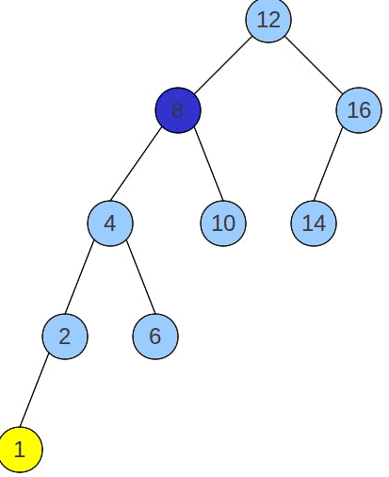
Figure 2. Insertion unbalances the tree
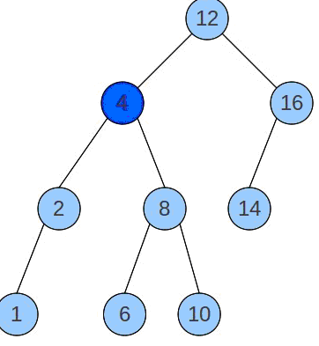
Figure 3. A single rotation re-balances the tree
In figure 2, “1” is added to the tree at the bottom left. The insert operation then walks back up the tree to see if the balance factor is maintained. “2” is balanced with a balance factor of 1, “4” is balanced with a balance factor of 1, but “8” is no balanced because it has a balance factor of 2 (its left tree height is 3 and its right tree height is 1, so the balance factor is 2.)
Figure 3 shows what the tree looks like after we rotate “8” down to the right. The rotation process involves moving “4” up to “8”s position and then fixing the tree by moving “4”s right subtree to the left subtree of “8.” In this case that involves moving “6” over to the left child of “8.”
Whenever you find that the balance factor is broken when walking back up the tree in a left-left or right-right path back up the tree then the tree can be re-balanced with a single rotation. But if the balance factor is broken by a left-right or right-left path then the tree requires a double rotation to restore the balance.
Figure 4 shows this scenario in the simple case of building a tree with nodes 1, 3, 2.
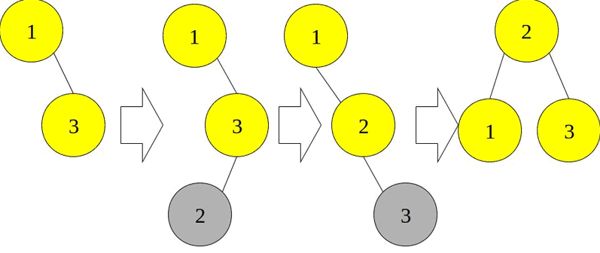
Figure 4. Double Rotation of an AVL Tree
In figure 4, when “2” is added to the tree, node “1” is unbalanced because the height of its left subtree is 0 and the height of the right subtree is 2 so 0 – 2 = -2. Because the path between node “1” and node “2” is right-left, we need to perform a double rotation: first “2” must be rotated up to “3”s position and then rotated up to “1”s position. This double rotation restores the tree to AVL balance.
Figures 5, 6, and 7 show the double rotation in a more complex example.
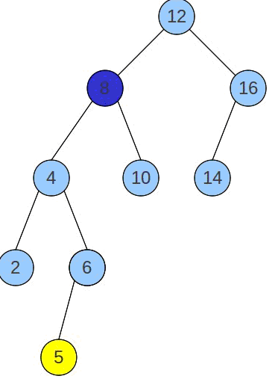
Figure 5. Tree becomes unbalanced when adding node “5”
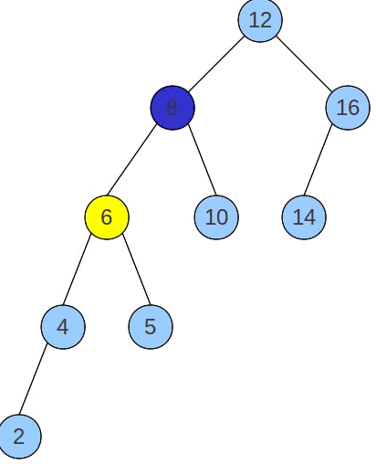
Figure 6. After the first rotation in a double rotation
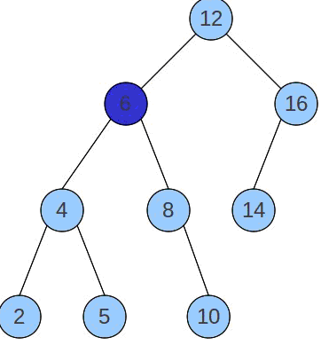
Figure 7. Re-balanced tree
Figure 5 shows a tree that becomes unbalanced at node “8” when the “5” node is added. The two steps down from “8” to the unbalanced subtree are left-right, so the first thing that we need to do to restore balance is to “6” up to “4”s position (figure 6). In essence this step causes the balance to be broken in a left-left fashion, which we know how to fix with a single rotation. We then perform the single rotation that moves “6” up to “8”s position and the tree's balance is restored.
Balancing AVL trees is well understood, but as you can see, the performance for inserting and removing an item can be cumbersome. After you insert an item into the tree you have to walk up the tree and examine the balance factor of every node up to the root and, if necessary, perform either a single or double rotation to restore the tree's balance. Removing an item is similar: remove the item, reassemble the tree by moving the greatest node in the left subtree to the place where the removed node was, and then check the balance of the tree and each node.
Red-black trees, which we'll explore in the next section, are less stringent on their definition of “balance,” but offer faster insert and delete operations. In general red-black trees maintain a fast log(N) lookup time, but they can be a bit slower than AVL trees because of a looser definition of balance.
Hopefully this brief review of AVL trees has given you an appreciation for the work required to maintain the balance of a binary search tree. AVL trees are easy to understand and serve as a basis for more advanced algorithms, such as red-black trees, whose details may obscure the goals that AVL trees cleanly illustrate.

Red-Black Trees
Thus far in this series I reviewed the challenges that one can face when building a binary search tree and the necessity to "balance" a tree. An unbalanced tree, in the worst case, can run in O(N) time, while a balanced tree runs in log(N) time, therefore it is important for you keep your tree balanced. There are various algorithms that can be employed to balance a tree, the first of which is called an AVL Tree and the more popular, but more complicated one, is called a Red-Black Tree.
AVL Trees balance a binary search tree by ensuring the "AVL-ness" of the tree after every addition or removal of a node from the tree. The AVL-ness of a tree means that at any given node, the height of the left sub tree minus the height of the right sub tree is 1, 0 or -1. If the height is +/- 2 then the tree is balances through either a single or a double rotation. AVL trees are very balanced, but as you might surmise, the amount of time required maintaining the balance can be detrimental to the overall performance of the tree for insert and removing operations.
Red-Black trees relax the balance of the tree in favor of an algorithm that is faster for insert and remove operations, but may be marginally slower for search operations. Red-black trees were first created in 1972 by Rudoff Bayer and were called "symmetric binary B-trees," but renamed red-black trees in a 1978 paper by Leonidas J Guibas and Robert Sedgewick.
In short, red-black trees define the following five requirements for its trees:
- A node must be either black or red.
- The root node is black.
- All leaves are black.
- Both children of every red node are black.
- Every path from the root to a leaf has the same number of black nodes.
These five rules may not sound like they lead to a balanced tree, but between rule 4 and 5 you can prove that at most the height difference between the left and right subtrees can be at most log(n): if the left sub tree has all black nodes and its height is log(n) and the right subtree has alternating red-black nodes then, because the tree cannot have two red nodes in a row, the maximum height of the right sub tree would be 2log(n), which by order of complexity is still log(n). But as it turns out, the implementation details for inserting or a removing an element from such a tree are much faster than the constant rebalancing required to manage an AVL tree.
Inserting a node into the tree follows the same binary search tree pattern to find the location where the node should be inserted:
- The first step is to walk down the tree finding its ultimate location. For example if you're inserting 5 into a tree whose root is 10, then you would traverse down to the left. Then say the node to the left of 10 is 4 then you would turn right with your 5, and so on.
- When walking down the tree, when you find a black node with two red children, make the node red and its two children black.
- If the node's parent is red (meaning that we now have two red nodes in a row) then perform either a single or double rotation (see the last section) in order to fix it.
- Once you reach the position where you are going to insert the node, insert it as a red node with two null black children.
Figures 1-4 demonstrate how this process works when building a tree. The figures were taken from Mark Allen Weiss's booth, Data Structures and Problem Solving using Java, from which I used to teach data structures and algorithm analysis, but I did not find it in the InformIT catalog.
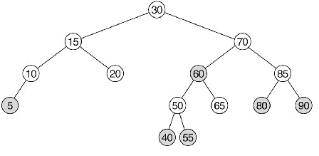
Figure 1 Red-black tree before the insertion of node 45
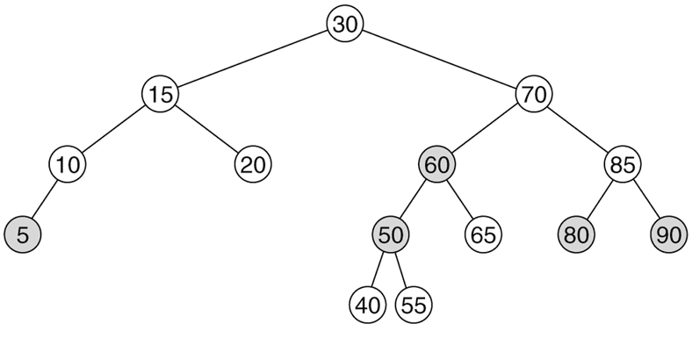
Figure 2 Swapping the color of node 50 because it has two red children causes a violation; because the violation is on the outside, a single rotation fixes it
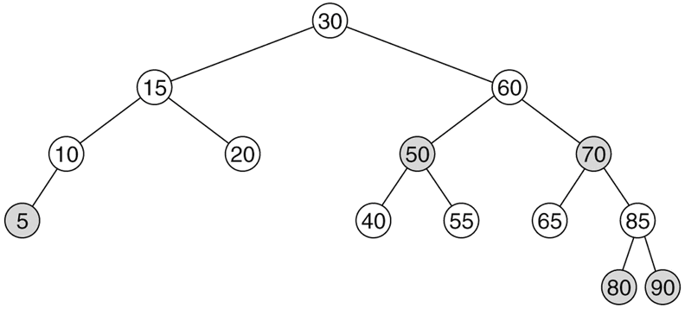
Figure 3 The red-black tree after the rotation, but before 45 is added
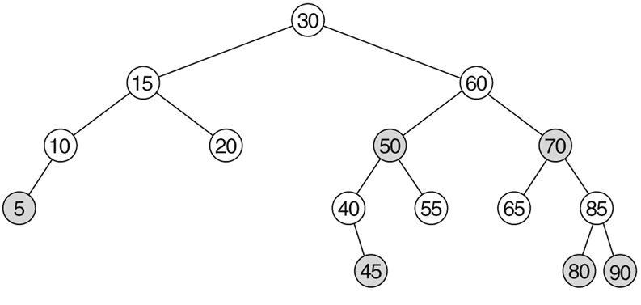
Figure 4 The final tree with 45 added as a red node
One of the differences between AVL trees and red-black trees is that you rebalance the red-black tree as you're traversing down it rather than inserting the tree and walking back up the tree. The result is that balancing an AVL tree during an insert can take 2 * log(n) operations rather than just log(n).
Removing a node involves finding the node to remove and then ensuring that removing it does not violate any of the 5 rules above. Specifically:
- Traverse down the tree and perform the following evaluations with the criteria, X is the current node, its sibling is T, and its parent is P.
- If X has two black children then: if T has two black children then flip the color, if T has an outer red child then perform a single rotation, if T has an inner red child then perform a double rotation.
- If X has at least one red child then fall through to the next level: if the child is black then execute the rules in step 2, if the child is red then rotate T and P, making X's new parent red.
Figures 5-8 show an example of how the various nodes are handled when traversing down a tree. Again, this is taken from Mark Allen Weiss's book.
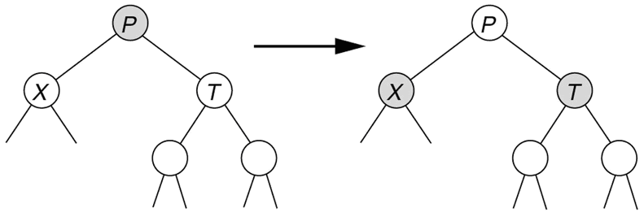
Figure 5 X has two black children and its sibling's children are black so flip their color
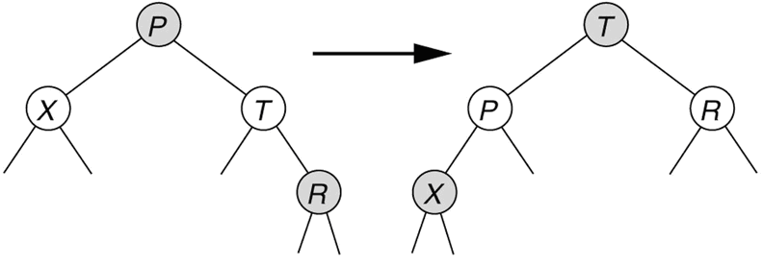
Figure 6 X has two black children and the outer child of its sibling is red so perform a single rotation
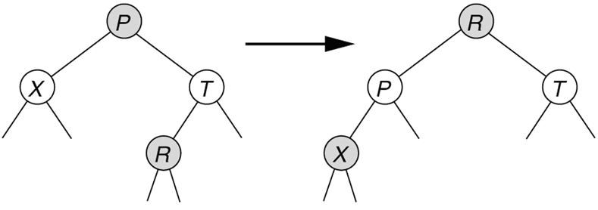
Figure 7 X has two black children and the inner child of its sibling is red so perform a double rotation
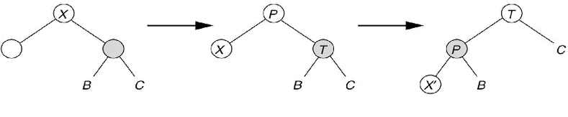
Figure 8 X is black and at least one child is red; if we fall through to the next level and land on a red child find, otherwise rotate a sibling and parent
While some of these rules may see arbitrary, they ensure that the tree stays relatively balanced while inserting and removing with minimal overhead. Because Red-black tree optimize insert and removal operations, they are well suited for trees in which the content changes frequently, which is how we tend to use trees. This is the main reason why Java's TreeMap and TreeSet make use of red-black trees for their implementations.

Hash Tables
At the beginning of this series I reviewed the difference between trees and hash tables and defined when you might use one over the other. As a quick recap, a hash table stores its information in a contiguous block of memory, akin to an array, and executes a hashing algorithm on its objects to determine how those objects map to indexes within the hash table. Because objects are hashed to indexes within the hash table it is possible to insert, retrieve, and remove objects from a hash table in constant time.
Trees, or more specifically binary trees, store objects in an ordered manner in a tree structure that allows you to find objects in the tree by traversing from the root to the desired node comparing the desired node to the current node to determine if the object is less than (in the left sub tree) or greater than (in the right sub tree). Trees use an algorithm, such as Red-Black, to ensure that the tree remains “balanced”, roughly meaning that at any node there are approximately the same number of elements in a tree's left sub tree as there are in its right sub tree (with each algorithm defining balance a little differently.) As long as a tree is balanced then it takes at most log(n) operations to find an object in the tree, where n is the number of elements in the tree.
With hash tables having constant time inserts, retrieval, and deletions and trees having log(n) time for inserts, retrieval, and deletions, hash tables are preferred if you can tolerate some of its limitations. Specifically, hash tables require more memory than trees, cannot retrieve elements in any natural ordering, and do not lend themselves well to situations in which you do not know approximately how many elements you expect to be contained in the hash table. In the previous two sections I reviewed the details for implementing trees with the AVL and Red-Black algorithms and in this section I present an overview of building a hash table.
Conceptually, the following observations can be made about hash tables:
- Hash tables are implemented using a contiguous block of memory of a fixed size, you can think of this as an array
- The individual slots in a hash table are referred to as buckets, where any given can be placed in a bucket
- A function, called a hash function, serves to map an object to an index within the hash table's array
- Because hash functions do not compute one-to-one mappings of objects to indexes, some objects will hash to the same index as other objects, which is referred to as a collision
- Collision resolution is the strategy employed to handle collisions that result from two objects that hash to the same value
- Collision resolution strategies vary from simple linear probing and quadratic probing to more complex double hashing to separate chaining
- As a hash table becomes sufficiently full, collisions will increase and hurt performance
- The “fullness” of a hash table is defined as the percentage of elements in the table that hold value. The fullness is compared to hash table's load factor, and if the load factor is exceeded then the hash table needs to be resized to hold more elements
- Because the hashing algorithm is designed to map objects to specific indexes in the hash table, if the hash table is resized then all of the items in the hash table must be rehashed to indexes in the new table. Thus, expanding a hash table is a non-trivial operation and requires n rehashes plus the constant time of allocating the new memory and moving keys from the old hash table to the new hash table.
- The Java HashMap delegates to the object's hashCode() function to perform its hashing algorithm and upon collisions it implements a rehash algorithm
- The default load factor for the Java HashMap is 75%
- The Java HashMap class uses separate chaining to handle collision resolution

Hash Function
A hash function must be simple to compute but also distribute the keys uniformly: if there are too many collisions then performance will degrade. One strategy for implementing a hash function is to convert the object to a String and then compute a hash that includes all elements in that String. The following code segment shows the Java String class's implementation of the hashCode() function:
@Override
public int hashCode() {
if (hashCode == 0) {
if (count == 0) {
return 0;
}
int hash = 0;
for (int i = offset; i < count + offset; i++) {
hash = value[i] + ((hash << 5) - hash);
}
hashCode = hash;
}
return hashCode;
}
Although simple to read, this hash function is difficult to fully understand without going through the mathematical exercise of examining the bits underlying how the hash value is computed. In short, the String class maintains its data in a character array and it iterates over the entire String character-by-character, reads the character's ASCII value (value[i]) and then updates the value of the hash using an algorithm that has been proven to be effective. The hash<<5 is equivalent to multiplying the hash value by 32 and subtracting the hash value helps offset the fact that the the value is being multiplied by 32 (a power of 2), which would effectively only shift bits around. Again, the important thing to consider is that the algorithm is simple, and hence quick, to execute and distributes keys uniformly.

Collision Resolution
I presented four strategies for handling collisions:
- Linear Probing
- Quadratic Probing
- Rehashing
- Separate Chaining
Linear probing is the simplest algorithm and what it means is that when a collision occurs then insert the object in the next bucket. And if the next bucket already has an element in it then move to the following, etc. The problem with this approach is that has collisions occur, they result in a sequential block of full buckets in the hash table. When this occurs, this sequential block is referred to as a primary cluster, and it means that as the fullness of the hash table increases that more and more elements hash into the cluster, which can quickly degrade constant time operations (and at worse if everything hashed to the same value you would end up with O(n) time operations.)
Quadratic probing eliminates primary clustering when collisions occur by choosing the next node based on the following type of algorithm:
H = hash value
New value = H + 1^2, H + 2^2, H + 3^2, ..., H + i^2
This avoids primary clustering because it distributes elements to buckets in a non-linear fashion. Thus, the only way that a cluster can occur is if the hash function hashes too many nodes to the same value (if the values do not match exactly then the new node will follow a different quadratic pattern.) This is conceptually good, but with a bad hashing function this can create secondary clusters, and thus is still not considered a good solution (although in practice is not that bad.)
Rehashing, sometimes referred to as double hashing, is the process of applying a secondary hashing function to the object when a collision occurs. It avoids both primary and secondary clustering, but an additional hash function can result in a measurable constant impact to performance. In general, a double hash function is the best solution to effectively resolve collisions.
Finally, separate chaining is a strategy in which each hash bucket contains a list of all elements that hash to the same value. When a collision occurs then the new colliding object is simply added to the end of the list. This strategy avoids traditional primary and secondary clustering and is inexpensive to append an object to the end of a list. Furthermore, because the hash table buckets contain lists of objects, the hash table theoretically never has to be resized because the hash table can support any number of items (but of course if your data is stored in a collection of lists then find operations will suffer so some separate chaining algorithms do resize when the fullness of the hash table exceeds the load factor.) On the other hand, if the hashing algorithm is sufficiently poor and a large number of objects hash to the same value then theoretically lookups could fall from constant time to linear time. For example, consider that all objects hash to the same value, then the hash table will have a single bucket that contains a linked list, which means that find and delete operations will take O(n) time.
As you can see, the focus of these collision resolution algorithms is to avoid collisions caused by a poor hashing algorithm. Therefore it is worth expending effort to ensure that your hash algorithm is good and that your hash table is sized appropriately (determine how many elements you expect your hash table to hold and set the initial capacity to that capacity multiplied by 1 1/3.

Summary
A hash table is an excellent data structure that provides constant time operations for insert, find, and remove, but requires that you know approximately how many objects you want to store in the hash table. As the hash table becomes fuller and approaches its capacity then the hash function becomes increasingly challenged in hashing objects to unique indexes. When two objects hash to the same index into the hash table it is called a collision and there are various strategies that define how to resolve those collisions.
The important things to remember about hash tables are that (1) they provide constant time performance for insert, find, and delete operations, (2) they require more memory than a tree, (3) resizing or expanding a hash table takes linear time, and (4) they do not maintain data in any natural order, like trees. If you have extra memory, do not need to output elements in natural order, and you know approximately how many items you are going to store, then a hash table is your best algorithmic choice.

Linked Lists
Last updated Mar 18, 2011.
I began my overview of different data structures by reviewing the differences between implementations of Java collection interfaces and presented conditions about when you might choose one over another. One of the interfaces that I presented was the List interface and compared two data structures that support lists: arrays and linked lists. In that review I said that arrays were better when you knew your memory requirements (how many objects you intend to store in the array) and you needed to access items randomly whereas linked lists were better if you did not know how many objects you intend to store and only ever need to display the contents of a list in the order it was built.
While this may all sound good in principle, you might gain a better appreciation for the difference by looking at how a linked list is implemented. In this article I implement a linked list in Java and demonstrate why I made the assertions that I did.
First, a linked list is a collection of nodes where one node has a reference (or in other programming languages such as C++, a pointer) to the next node in the list. Thus you start from the root or head of the list an traverse over the list by moving your reference repeatedly to the next element in the list. Figure 1 shows this graphically.
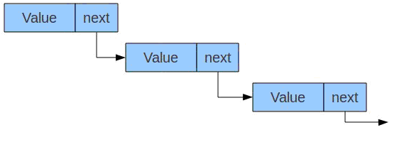
Figure 1 Linked List
As you can see in figure 1, each node has a value and a reference to the next node in the list. And the last node in the list points to nothing, or in programming vernacular, it points to null. Thus, to add a new element to the list, you would traverse over the list to the end and append the item to the end of the list by updating the last node's next pointer to point to the new node and configure the new node's next pointer to point to null. Note that the way that you know that you've reached the end of the list is that the next pointer points to null. If you wanted to insert a node rather than add a new node then you could perform some reference manipulation to insert the item anywhere:
- Find the node after which you want to insert the new node
- Set the new node's next pointer to point to the next element of the insertion node
- Set the insertion node's next to point to the new node
Likewise, removing a node involves updating the references:
- Point the previous node's next pointer to the deleted node's next pointer
- Delete the node and the list will never find the node because the path to it has been removed
The problem that you should be able to see in this implementation is that if you are searching for a node that you have to start at the beginning of the list and walk from the beginning to the end until you find the node you're looking for. In other words, there is no mechanism to randomly access any node in the list.
Linked lists come in three flavors:
- Singly linked: you always start at the head of the list and walk through the list linearly
- Doubly linked: you can move both forwards and backward through the list (each node has a previous reference and a next reference.) This allows you to start at the end of the list and walk backwards through it
- Circularly linked: the last node in the list points to the first node in the list so you could walk indefinitely over each element in the list
In this example I implement a simple singly linked list with the following two components:
- Node: a container for a value that holds a reference to the next node in the list
- LinkedList: the parent class that contains the root node and provides methods for interacting with the list
The node class is shown in listing 1.

Listing 1. Node.java
package com.geekcap.informit.dsaa.linkedlist;

/**
* Linked List Node
*
* @author shaines
*/
public class Node
{
public T value;
public Node next;

public Node()
{
}

public Node( T value )
{
this.value = value;
}
}
As you can see in listing 1, the Node class has two parameters: the value and the next reference. The value contains the value contained in the node while the next reference is used by the LinkedList class to iterate over the list. The only thing that might be confusing is the use of generics. Rather than storing the value as a generic object that would need to be casted by the client, the Node class uses the generic “T” to both make it easier for the client to retrieve its value as well as to add type safety to the class. When you create an instance, you must specify the type of Node you're creating and then you cannot add any different types to the list. For example, if you used an Object, you could add both Integers and Strings to the list, but what would happen if you tried to execute intValue() on a String? It would fail! But if you told the Node that it only contains Integers then you would not be able to add a String to it and the problem would be avoided. We implement the same philosophy in the LinkedList class, shown in listing 2.

Listing 2. LinkedList.java
package com.geekcap.informit.dsaa.linkedlist;

/**
* Linked List example
*
* @author shaines
*/
public class LinkedList
{
private Node root;

public LinkedList()
{
}

public void addElement( T value )
{
if( root == null )
{
root = new Node( value );
root.next = null;
}
else
{
// Find the next open node
Node node = root;
while( node.next != null )
{
node = node.next;
}

// Add the new value to the list
Node newNode = new Node( value );
newNode.next = null;
node.next = newNode;
}
}

public void showList()
{
if( root == null )
{
System.out.println( "List is empty" );
}
else
{
Node node = root;
while( node.next != null )
{
System.out.println( "Value: " + node.value );
node = node.next;
}
System.out.println( "Value: " + node.value );
}
}
}
The LinkedList class is not a full implementation of a linked list, but it provides methods to add new elements and to display the contents of the list. The addElement() method iterates from the root of the list (sometimes called the head) to the end of the list and then adds the new element to the end of the list. The showList() method iterates over the list by repeatedly referencing the Node's next attribute until a null next is found, displaying the value during the traversal. This should give you a flavor for how list traversal is performed.
Listing 3 shows a simple test class that illustrates how to use the LinkedList.

Listing 3. LinkedListTest.java
package com.geekcap;

import com.geekcap.informit.dsaa.linkedlist.LinkedList;

/**
* Sample test client
*
* @author shaines
*/
public class LinkedListTest
{
public static void main( String[] args )
{
LinkedList list = new LinkedList();
System.out.println( "List before: " );
list.showList();
list.addElement( "One" );
list.addElement( "Two" );
list.addElement( "Three" );
System.out.println( "List after: " );
list.showList();
}
}
The output of listing 3 is:
List before:
List is empty
List after:
Value: One
Value: Two
Value: Three
Listing 3 creates a new list that holds Strings (recall the discussion above about generics), displays the contents of the list before it holds items (empty), adds three items, and then displays the list afterwards.
The important thing to notice about linked lists is that you must start at the root and walk across the list for add, insert, remove, or find operations. If the item you're looking for is last then this data structure has an order of complexity of linear time, or O(N). Thus if you have a large data set then the performance will degrade as you add more items. But in terms of memory, the linked list only holds the value object at a reference for each next node. If you were to create an array you would have to size it to hold more than the number of elements currently in the collection in case new items were added. If an array exceeds its size then a new array must be allocated and all of the elements in the old array moved to the new array. This is not a problem that you would ever encounter with a linked list because it can conceivably grow indefinitely (or until you run out of memory.) This shows that linked lists are versatile with respect to memory, but it comes at a cost of linear time operations as compared to constant time operations when using an array.

Summary
This section of the Java Reference Guide provides a review of core computer science principles that every developer should understand. Whether you do not have a computer science background or it has been several years since you set foot in a computer science classroom, this section should provide you with a review of topics that you need to make optimal decisions when choosing Java data structures.
In the first installment of this series I presented a comparison of trees and hash tables, which provide the foundation for Java’s HashSet, HashMap, TreeSet, and TreeMap collection classes. The semantics of using the hash table-based or tree-based implementation of a set or map is arbitrary, but the selection of which one to use is far from arbitrary. By understanding how hash tables and trees work and the nature of and the operations to be performed on data contained within them, you should be equipped with enough information to make the optimal choice for the business problem you are solving.
In the second installment of this series I presented a comparison of arrays and linked lists. If you know the indices of the objects you’ll be working with, arrays provide constant time add, update, remove, and search operations, but they do at the cost of requiring extra unused memory and potentially expensive resize operations. Linked lists provide constant time adds, only consume the amount of memory needed to host their objects, and do not suffer from the resize cost that arrays do, but they do not support random access. Thus search, update, and remove operations can potentially require the examination of all items in the list, even if you know the index of the item you want. Your business needs will dictate the best data structure for your business problem.
And in the third installment I presented an overview of Stacks and Queues. Stacks are used frequently when parsing data and in mathematical operations while Queues are used whenever you need to order objects or tasks.

